
Story

Date | 24 September 2024
Team ID | NEHAL YADAV
Project Name | FORMULA 1 Race Intelligence Dashboard Analysis Report 2010-2026
Maximum Marks | 5 Marks

Tableau Story Design &amp; Narrative Report
By using stories in Tableau, you can effectively communicate complex data in a way that is both interactive and engaging. The F1
Race Intelligence Story guides team strategists, broadcast journalists, and FIA compliance analysts through a logical sequence of
17 seasons of F1 insights.
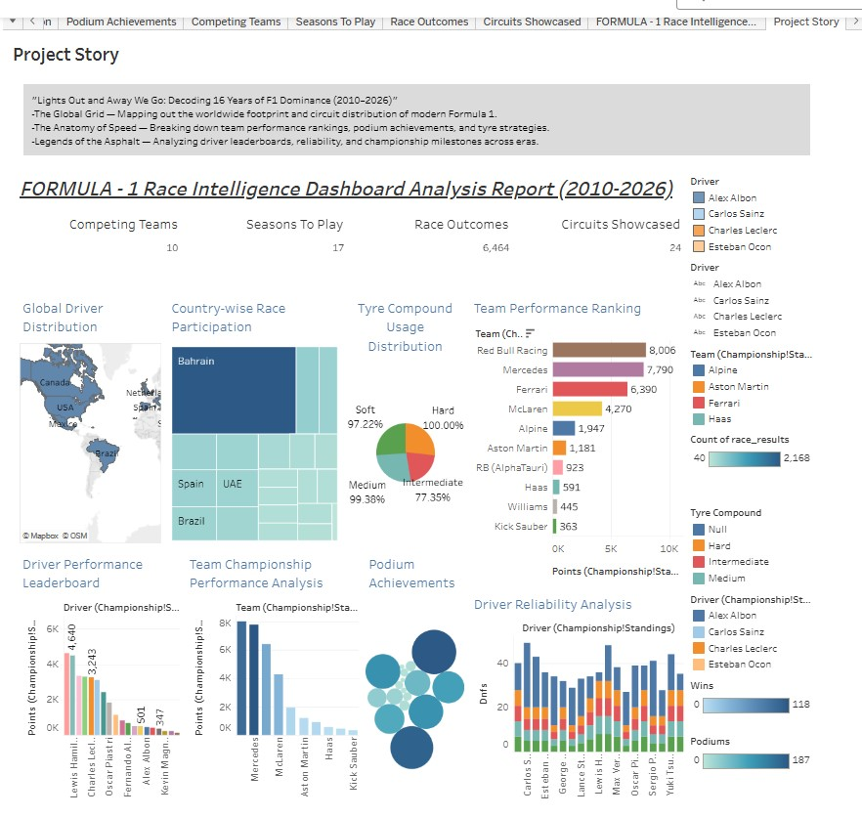
Activity 2:
Publish Story on Tableau Public and Paste Public link below
https://public.tableau.com/app/profile/nehal.yadav1063/viz/FORMULA-1RaceIntelligenceDashboardAnalysisReport2010-2026/ProjectStory

